# Mental Health Application Project Description

**Project Name:** *Insert Here*

**Overview:**  
… a user-friendly web and mobile application designed to promote mental health and provide accessible resources for individuals seeking support. The platform will cater to a diverse population by offering a multilingual interface (English, Shona, and Ndebele) and a comprehensive directory of certified mental health professionals.

**Core Features:**

1. **User-Friendly Interface:**
   * Simple navigation and clean design
   * Multilingual support (English, Shona, and Ndebele)
2. **Practitioner Directory:**
   * Comprehensive list of certified mental health professionals
   * Profiles, specializations, and contact information
3. **Teletherapy Services:**
   * Secure, confidential video and audio consultations
   * Integration with popular video conferencing tools
4. **Local Events Calendar:**
   * Regular updates on mental health events and community support
   * Filtering by location and event type
5. **Mental Health Resources:**
   * Educational materials on mental health topics
   * Self-help guides and coping strategies
6. **Emergency Contacts:**
   * Quick-access section for immediate assistance
   * Hotlines and nearby clinics

**Development Roadmap:**

**Web Application (Phase 1):**

1. Design and prototyping (4 weeks)
2. Front-end development (8 weeks)
3. Back-end development (8 weeks)
4. Testing and debugging (4 weeks)
5. Launch (2 weeks)

**Mobile Application (Phase 2):**

1. Design and prototyping (4 weeks)
2. Front-end development (8 weeks)
3. Back-end integration (4 weeks)
4. Testing and debugging (4 weeks)
5. Launch (2 weeks)

**Pictures:**

Here are some sample page designs to illustrate the application's layout and features:

**Home Page:**

* Header with navigation menu
* Hero section with introductory text and call-to-action (CTA) buttons
* Featured sections for practitioners, events, and resources

**Practitioner Directory:**

* Search bar with filters (location, specialization, language)
* List of practitioners with profiles, photos, and contact information

**Teletherapy Services:**

* Secure video conferencing interface
* Audio consultation option
* Scheduling system for appointments

**Local Events Calendar:**

* Calendar view with event listings
* Filtering by location and event type
* Event details with descriptions, dates, and times

**Mental Health Resources:**

* Library of educational materials and self-help guides
* Categories and tags for easy searching
* Downloadable resources (PDFs, eBooks)

**Emergency Contacts:**

* Quick-access section with hotline numbers and clinic information
* Nearby clinic locator with map integration

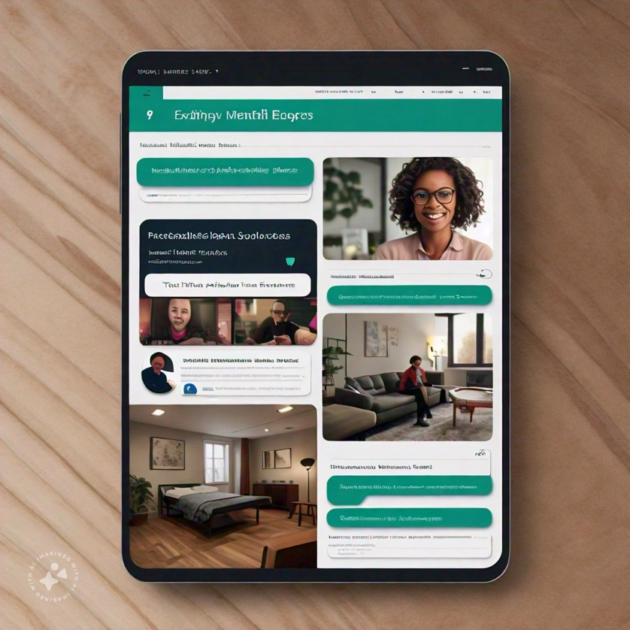

**Development Timeline and Structure**

**Front-end (Client-side)**

* **React** or **Angular** framework for building the user interface
* **JavaScript** for dynamic client-side functionality
* **HTML/CSS** for structuring and styling the application

**Components**

* **Header**
  + Navigation menu
  + Logo
* **HeroSection**
  + Introductory text
  + Call-to-action (CTA) buttons
* **FeaturedSections**
  + Practitioners
  + Events
  + Resources
* **PractitionerDirectory**
  + Search bar
  + Filter options (location, specialization, language)
  + Practitioner list with profiles, photos, and contact information
* **TeletherapyServices**
  + Video conferencing interface
  + Audio consultation option
  + Scheduling system
* **LocalEventsCalendar**
  + Calendar view
  + Filtering by location and event type
  + Event details
* **MentalHealthResources**
  + Library of educational materials
  + Categories and tags
  + Downloadable resources
* **EmergencyContacts**
  + Quick-access section
  + Hotline numbers and clinic information
  + Nearby clinic locator

**Back-end (Server-side)**

* **Node.js** or **Django** framework for building the server-side logic
* **Database** (e.g., **MongoDB**, **PostgreSQL**) for storing data

**API Endpoints**

* **GET /practitioners**: Retrieve list of practitioners
* **GET /events**: Retrieve list of events
* **GET /resources**: Retrieve list of resources
* **POST /teletherapy**: Schedule teletherapy appointment
* **GET /emergency-contacts**: Retrieve emergency contact information

**Database Schema**

* **Practitioners**
  + ID
  + Name
  + Specialization
  + Location
  + Contact information
* **Events**
  + ID
  + Name
  + Description
  + Date and time
  + Location
* **Resources**
  + ID
  + Title
  + Category
  + Tags
  + File (PDF, eBook)
* **Teletherapy Appointments**
  + ID
  + Practitioner ID
  + User ID
  + Date and time
* **Emergency Contacts**
  + ID
  + Name
  + Hotline number
  + Clinic information